Autopoll
Online polls Automated

Application Version 1.03
Document Version 1.01
Introduction

Autopoll is an application to automate the voting on online polls. The application can be customized to make the polling with out user assistance in most of the online polls. This document explains in a step by step manner how to configure the application and make it vote a web poll. For this sample we have used the poll found in the following URL

http://www.settingtheworldtorights.com/node/130

How does this application work?

- Start the application by selecting it from the Start menu or by double clicking the Autopoll.exe
- The screen will look like the following
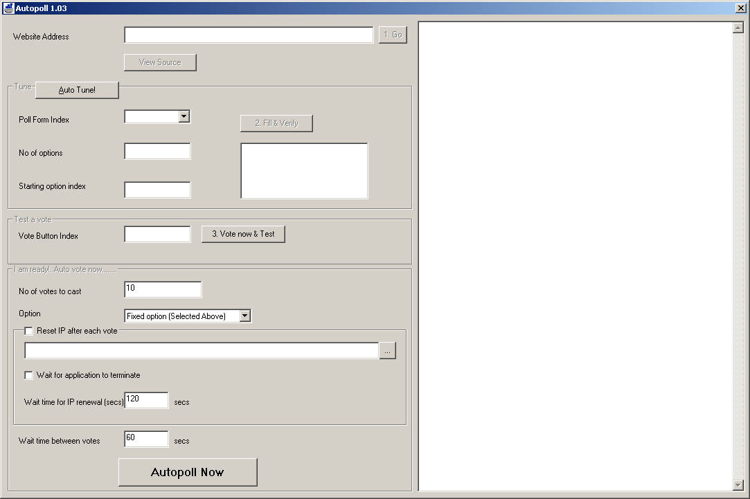

- To make the application ready for polling on the site, we need to configure and train it. This is a 3 step process.
  - Load the site
  - Tune it and Verify the parameters
  - Test by a sample vote
- Once the above three steps are completed successfully, the application is ready to sit and do the voting on its own.

Configuring the application

1. Enter the URL of the page in the website address.

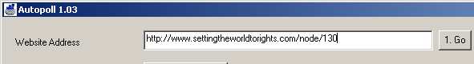

Note: If the poll is inside a frame of the main page, you need to enter the URL of the page inside the frame instead of the main page.

2. Click Go button. This will load the page on the browser located on the right side. Once the site is fully loaded you will get a message

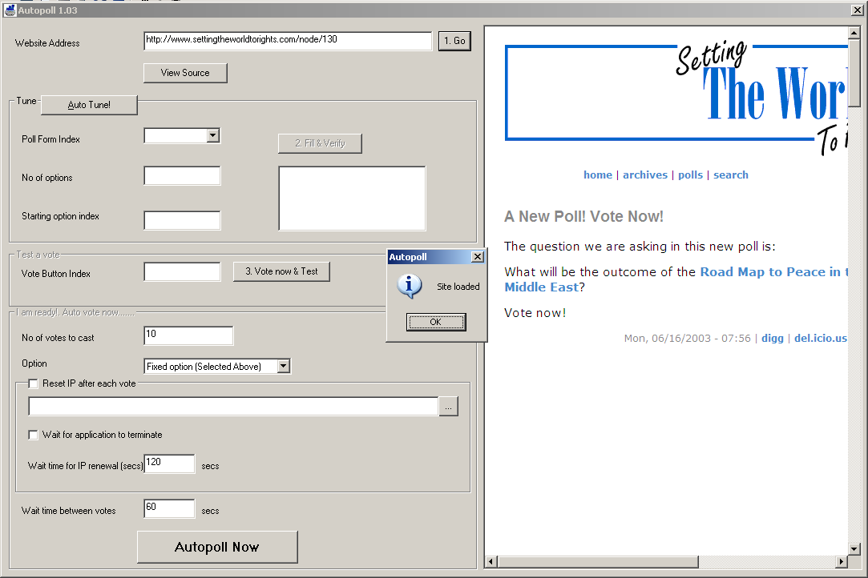

3. Click OK to continue
4. Scroll the mini browser so that the poll is visible properly

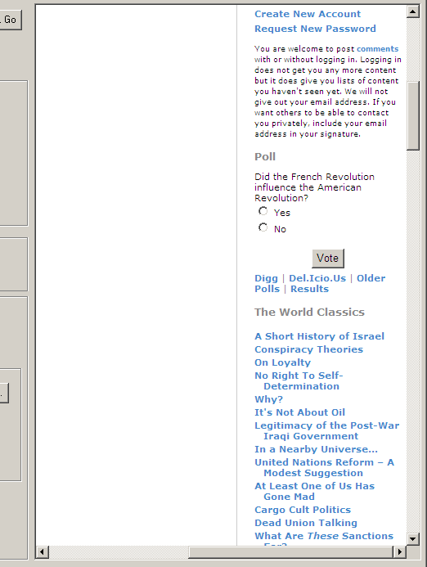

- Now we need to tune the application so that it can locate the poll form on the web page. This requires us to key three parameters.
  - The form poll form index – It is the sequence number of the <FORM> tag with in the HTML source where the poll form is located. The sequence start with 0
  - No of Options – Number of options available for polling.
  - Starting Option Index – This is the sequence of number of the first option element inside the selected form tag
If you don’t know these values properly, you can click Autotune button to make the application automatically find these values for you. In most of the cases application will fill these values correctly. If not, you can enter the values manually by viewing the source of the page (Click View Source button)

- In the above sample the values will look as shows below
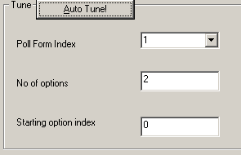

- Now you need to verify that the application has tuned to locate the poll
- Click on Fill & Verify
- This will fill the list box with the names of the options in the poll. Do not worry about the names shown here. They are actually the control names in the source code. Just compare the number of options shown here with the number of options in the poll.
In our example since there are two options (Yes and No) you will get the list like this
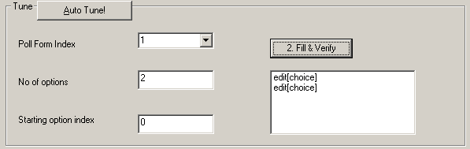
Now to verify this, click on the first option the corresponding choice in the poll will be selected automatically.
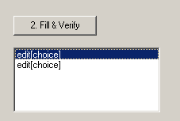 
Click the second option, the second choice in poll will be selected.

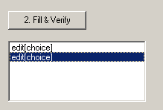 
Click all remaining options to verify that all options are working fine.
- If the above step is not working properly you need to fine tune again by changing the parameters explained in Step 5
- Once the application has identified and tuned to sync with the poll. You can ask the application to make a sample vote for you to ensure that the Autopoll is ready to do the voting on its own.
- Once again, select the option which you want to vote by clicking on the option shown in the list box below the ‘Fill & Verify’ button. The corresponding voting option will be automatically selected
- Click ‘Vote now and Test’ to test your vote
- Your mini browser will indicate the result of voting
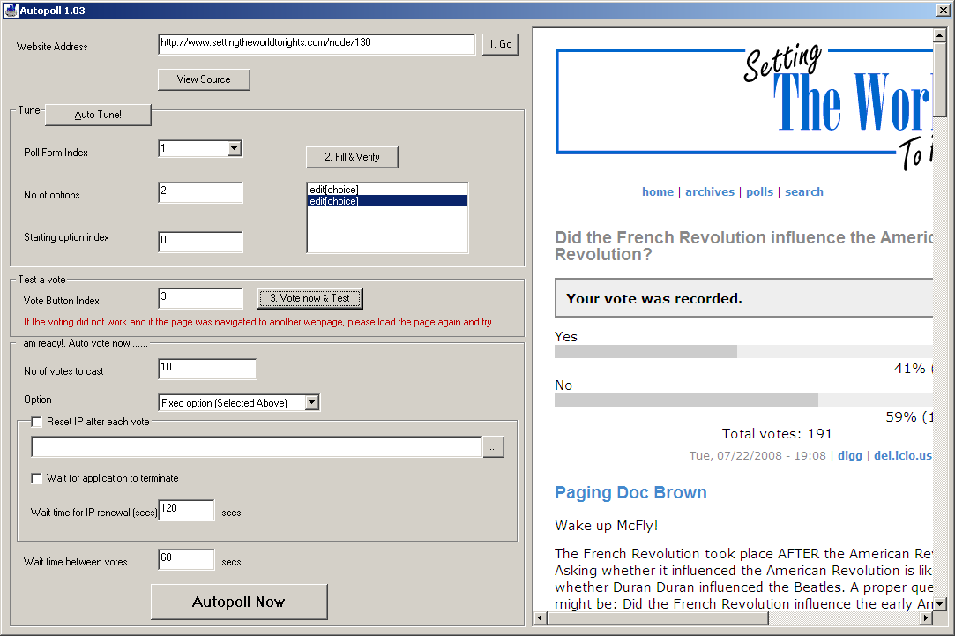

Kick start the engine

Once the tuning and configuration is done successfully and the application is ready to vote, you can go through the following steps to start the engine to do the auto polling.

- Enter the number of votes to cast


- Select the type of choice making the application need to use. There are two options available
Fixed Option – It uses a fixed choice for all the votes. The choice you selected in step 12 of the previous section will be used for voting.
Random Option – The choice will be randomly selected by the application
- Reset IP after each vote
Most of the site will not allow you to vote only once. When you try for the second time, it will simply display a message and stops you from voting. This is done by using your IP address and compares it with their IP database. But you can cheat the application by using a different IP address for each vote. Getting new IP address differs by the kind of internet service you use. But Autopoll can be configured to execute any application that is capable of changing the IP address of the system. Autopoll will execute this EXE every time before it casts a vote. This external application can also be a BAT or COM file.
- Wait for application to terminate
This option is applicable only if you have selected an application to renew the IP in the step 3. Some IP renewing applications will exit itself once the renew is complete, but others still continue to run in the background after changing the IP (Example is few browser based applications that come with the modem). If your application closes itself after the renewal, you need to select this option
- Wait time for IP renewal
This option need to be filled in two cases
  - When your external application does not terminate after the IP renewal, you want to wait for ‘n’ seconds before the next vote to make sure that the IP has indeed renewed
  - Even if your application closes, the actual IP renew may take further ‘n’ seconds.
In the above cases enter this time in seconds as a buffer.

- Wait time between votes
Once a voting is done, your vote will be posted to the web server and the web server displays a new page with the results. The application cannot make another vote when the above process is going on, so it is mandatory to have a wait time between votes so that you are allowing your vote to be posted and processed by the server. The value given here depends on your connection speed. It is recommended to use 10 secs or more.
- Sample screen with all parameters are shown below
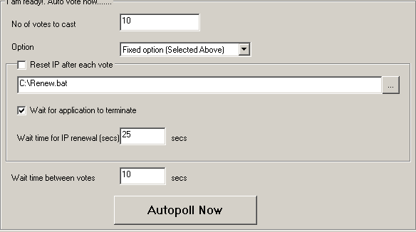
- Once you are ready, click on ‘Autopoll Now’. The application will start the polling automatically and display a message once the voting is over

